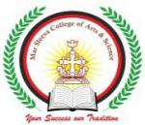MAR SLEEVA COLLEGE OF ARTS AND SCIENCE
MURICKASSERY
DEPARTMENT OF ENGLISH
REPORT OF RECITATION COMPETITION

The Department of English organized an interdepartmental Recitation Competition on 21 June 2021.
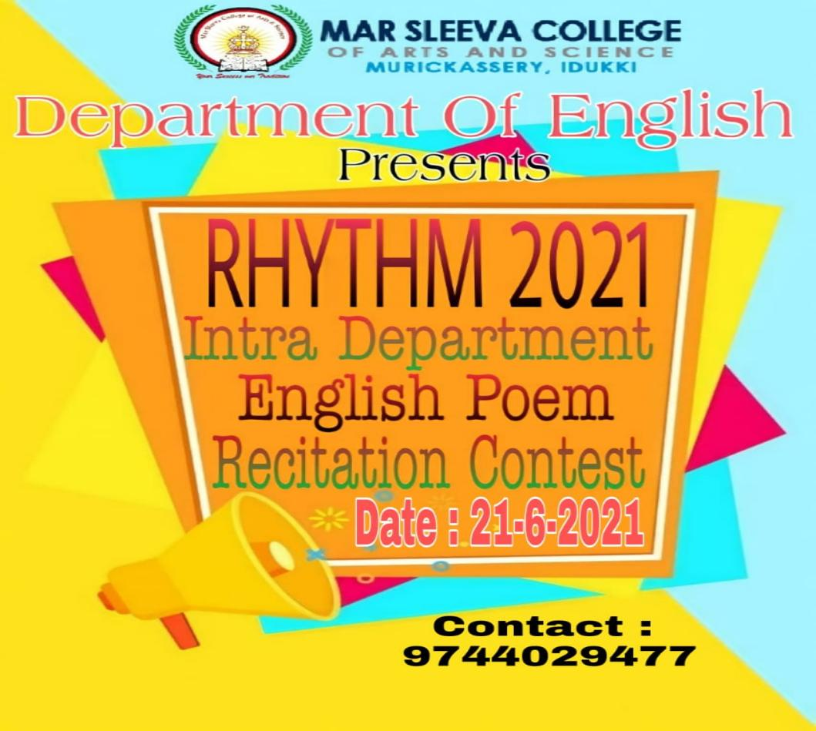
The participants were asked to send their videos on 21 June 2021 before 06 PM to the English Department Mail ID.The staff and student coordinators shared the rules and regulations of the competition. Attractive prizes were also announced for the winners.

Many students from the department participated in the competition. The competition was strictly valued on the basis of the talent of the students. Ms.Maria Susan Jose and Mr.Jobin Joseph were the staff coordinators. Akhil Sabu and Alfy C Jose served as the student coordinators. Some of the screenshots are attached below:

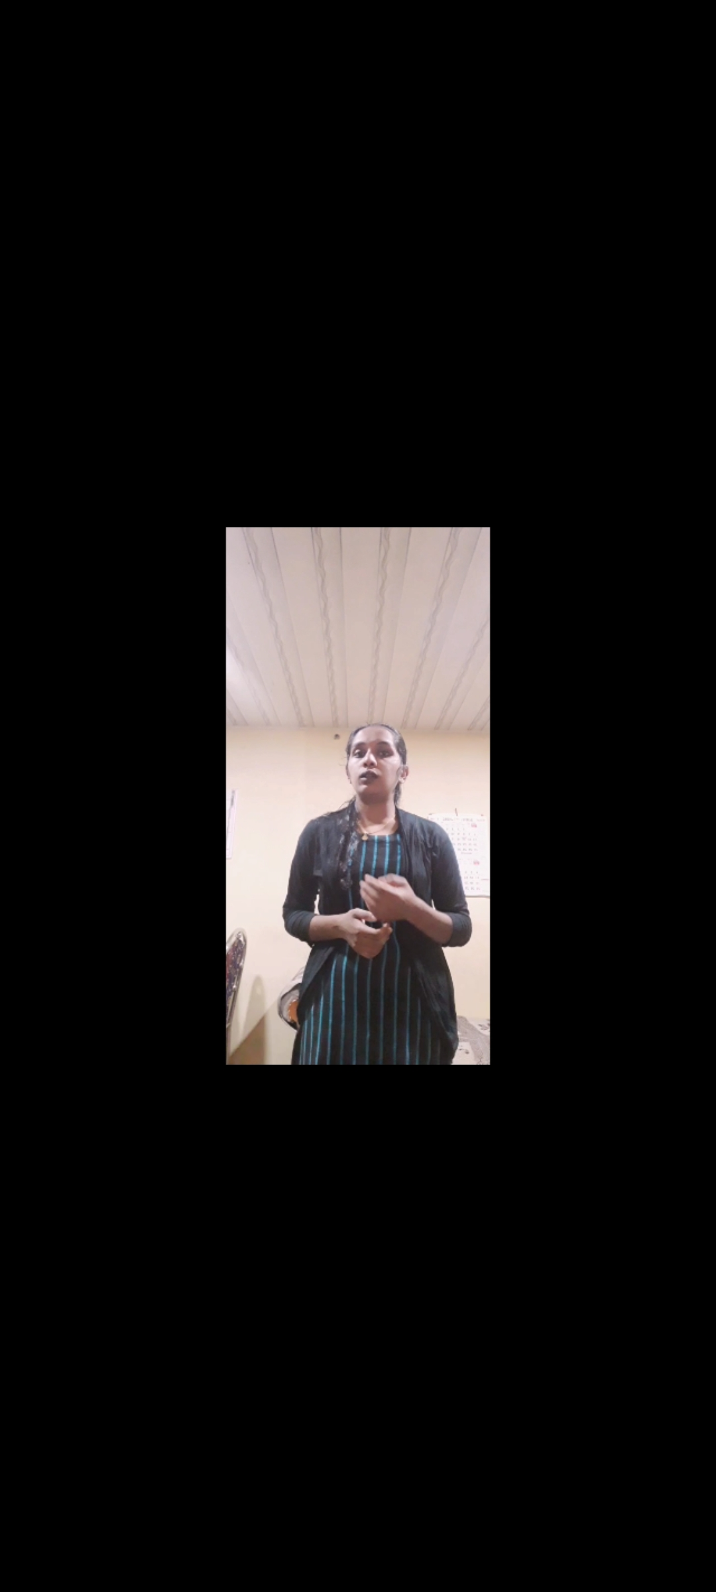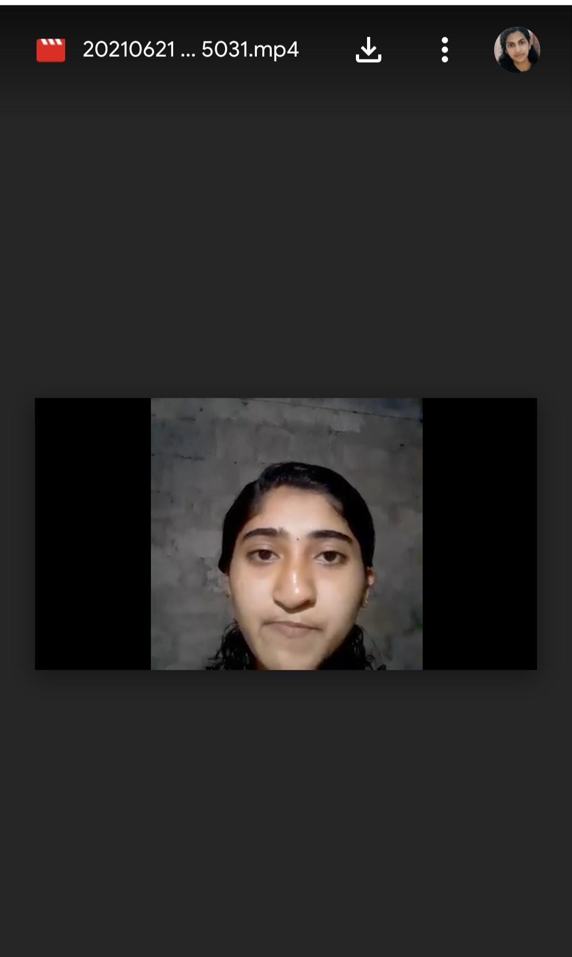
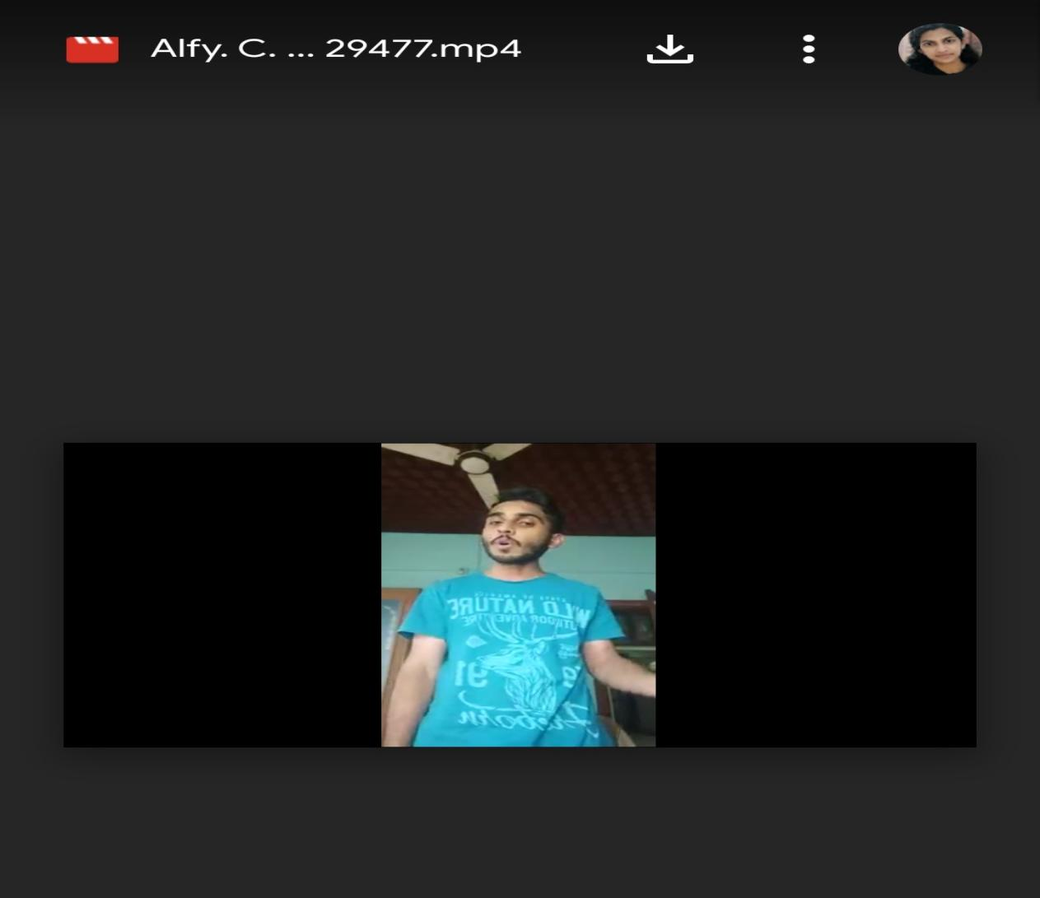

The judgement was based on the overall performance ,articulation, accuracy ,voice and articulation. Ms.Maria Susan Jose and Ms.Anu Baby were the judges of the competition. The Winners of the competition were:
- Amritha P.S(E3)
- Alfy C Jose (E3)
- Varsha Shaji (E2)

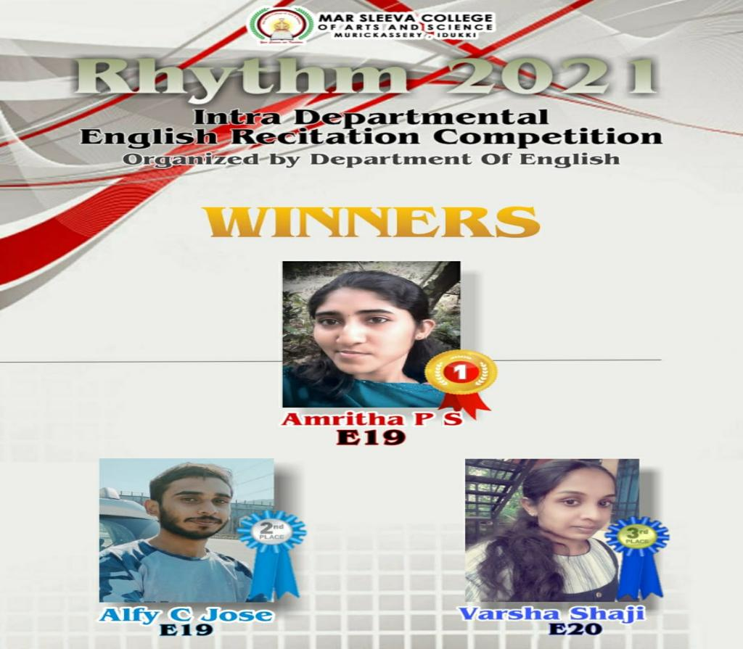

The competition was a different experience for the students. The effort taken by the participants were highly appreciated.

Signature Signature Signature
Head of The Department IQAC Coordinator Principal

